What is Network Topology?

Topology defines the structure of the network of how all the components are interconnected to each other. There are two types of topology: physical and logical topology.

Types of Network Topology

Physical topology is the geometric representation of all the nodes in a network. There are six types of network topology which are Bus Topology, Ring Topology, Tree Topology, Star Topology, Mesh Topology, and Hybrid Topology.

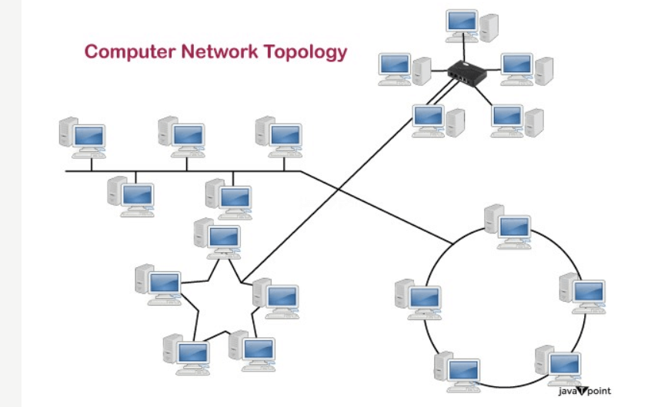

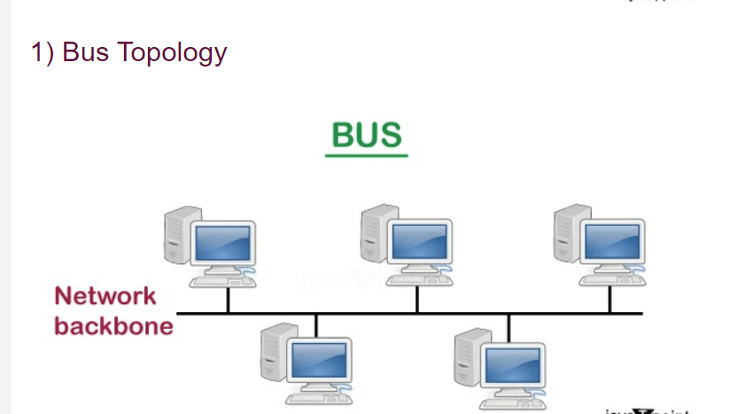

* The bus topology is designed in such a way that all the stations are connected through a single cable known as a backbone cable.
* Each node is either connected to the backbone cable by drop cable or directly connected to the backbone cable.
* When a node wants to send a message over the network, it puts a message over the network. All the stations available in the network will receive the message whether it has been addressed or not.
* The bus topology is mainly used in 802.3 (ethernet) and 802.4 standard networks.
* The configuration of a bus topology is quite simpler as compared to other topologies.
* The backbone cable is considered as a **"single lane"** through which the message is broadcast to all the stations.

### Advantages of Bus topology:

* **Low-cost cable:** In bus topology, nodes are directly connected to the cable without passing through a hub. Therefore, the initial cost of installation is low.
* **Moderate data speeds:** Coaxial or twisted pair cables are mainly used in bus-based networks that support upto 10 Mbps.
* **Familiar technology:** Bus topology is a familiar technology as the installation and troubleshooting techniques are well known, and hardware components are easily available.
* **Limited failure:** A failure in one node will not have any effect on other nodes.

### Disadvantages of Bus topology:

* **Extensive cabling:** A bus topology is quite simpler, but still it requires a lot of cabling.
* **Difficult troubleshooting:** It requires specialized test equipment to determine the cable faults. If any fault occurs in the cable, then it would disrupt the communication for all the nodes.
* **Signal interference:** If two nodes send the messages simultaneously, then the signals of both the nodes collide with each other.
* **Reconfiguration difficult:** Adding new devices to the network would slow down the network.
* **Attenuation:** Attenuation is a loss of signal leads to communication issues. Repeaters are used to regenerate the

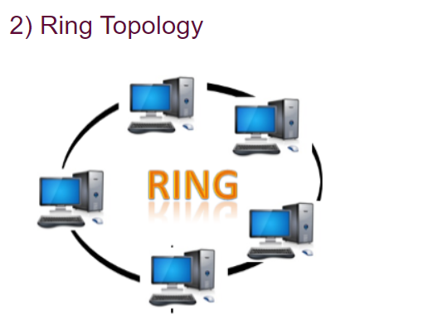

* Ring topology is like a bus topology, but with connected ends.
* The node that receives the message from the previous computer will retransmit to the next node.
* The data flows in one direction, i.e., it is unidirectional.
* The data flows in a single loop continuously known as an endless loop.
* It has no terminated ends, i.e., each node is connected to other node and having no termination point.
* The data in a ring topology flow in a clockwise direction.

### Advantages of Ring topology:

* **Network Management:** Faulty devices can be removed from the network without bringing the network down.
* **Product availability:** Many hardware and software tools for network operation and monitoring are available.
* **Cost:** Twisted pair cabling is inexpensive and easily available. Therefore, the installation cost is very low.
* **Reliable:** It is a more reliable network because the communication system is not dependent on the single host computer.

### Disadvantages of Ring topology:

* **Difficult troubleshooting:** It requires specialized test equipment to determine the cable faults. If any fault occurs in the cable, then it would disrupt the communication for all the nodes.
* **Failure:** The breakdown in one station leads to the failure of the overall network.
* **Reconfiguration difficult:** Adding new devices to the network would slow down the network.
* **Delay:** Communication delay is directly proportional to the number of nodes. Adding new devices increases the communication delay.

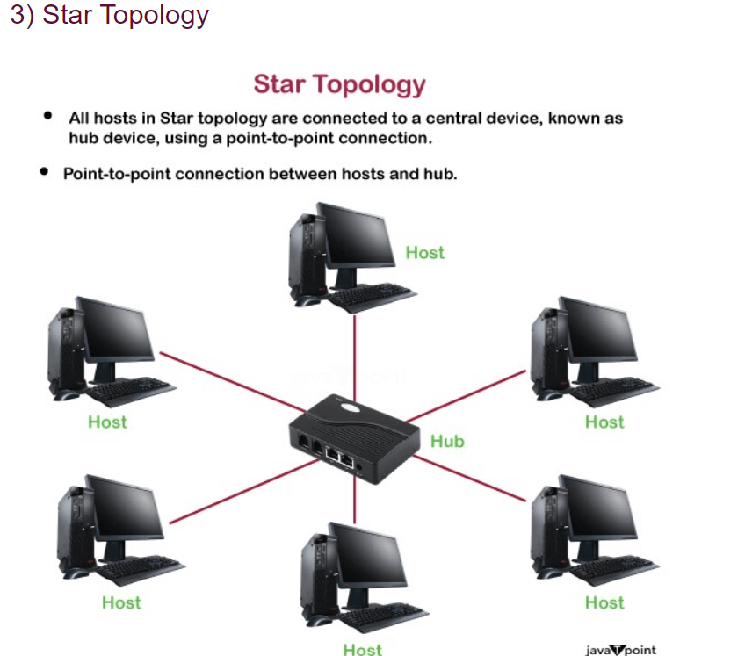

* Star topology is an arrangement of the network in which every node is connected to the central hub, switch or a central computer.
* The central computer is known as a **server**, and the peripheral devices attached to the server are known as **clients**.
* Coaxial cable or RJ-45 cables are used to connect the computers.
* Hubs or Switches are mainly used as connection devices in a **physical star topology**.
* Star topology is the most popular topology in network implementation.

### Advantages of Star topology

* **Efficient troubleshooting:** Troubleshooting is quite efficient in a star topology as compared to bus topology. In a bus topology, the manager has to inspect the kilometers of cable. In a star topology, all the stations are connected to the centralized network. Therefore, the network administrator has to go to the single station to troubleshoot the problem.
* **Network control:** Complex network control features can be easily implemented in the star topology. Any changes made in the star topology are automatically accommodated.
* **Limited failure:** As each station is connected to the central hub with its own cable, therefore failure in one cable will not affect the entire network.
* **Familiar technology:** Star topology is a familiar technology as its tools are cost-effective.
* **Easily expandable:** It is easily expandable as new stations can be added to the open ports on the hub.
* **Cost effective:** Star topology networks are cost-effective as it uses inexpensive coaxial cable.
* **High data speeds:** It supports a bandwidth of approx 100Mbps. Ethernet 100BaseT is one of the most popular Star topology networks.

### Disadvantages of Star topology

* **A Central point of failure:** If the central hub or switch goes down, then all the connected nodes will not be able to communicate with each other.
* **Cable:** Sometimes cable routing becomes difficult when a significant amount of routing is required.

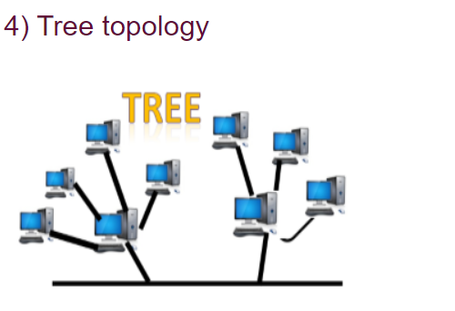

* Tree topology combines the characteristics of bus topology and star topology.
* A tree topology is a type of structure in which all the computers are connected with each other in hierarchical fashion.
* The top-most node in tree topology is known as a root node, and all other nodes are the descendants of the root node.
* There is only one path exists between two nodes for the data transmission. Thus, it forms a parent-child hierarchy.

### Advantages of Tree topology

* **Support for broadband transmission:** Tree topology is mainly used to provide broadband transmission, i.e., signals are sent over long distances without being attenuated.
* **Easily expandable:** We can add the new device to the existing network. Therefore, we can say that tree topology is easily expandable.
* **Easily manageable:** In tree topology, the whole network is divided into segments known as star networks which can be easily managed and maintained.
* **Error detection:** Error detection and error correction are very easy in a tree topology.
* **Limited failure:** The breakdown in one station does not affect the entire network.
* **Point-to-point wiring:** It has point-to-point wiring for individual segments.

### Disadvantages of Tree topology

* **Difficult troubleshooting:** If any fault occurs in the node, then it becomes difficult to troubleshoot the problem.
* **High cost:** Devices required for broadband transmission are very costly.
* **Failure:** A tree topology mainly relies on main bus cable and failure in main bus cable will damage the overall network.
* **Reconfiguration difficult:** If new devices are added, then it becomes difficult to reconfigure.

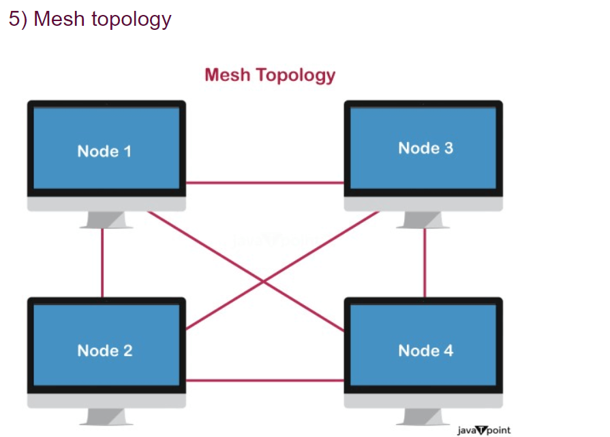

* Mesh technology is an arrangement of the network in which computers are interconnected with each other through various redundant connections.
* There are multiple paths from one computer to another computer.
* It does not contain the switch, hub or any central computer which acts as a central point of communication.
* The Internet is an example of the mesh topology.
* Mesh topology is mainly used for WAN implementations where communication failures are a critical concern.
* Mesh topology is mainly used for wireless networks.
* Mesh topology can be formed by using the formula:  
  **Number of cables = (n*(n-1))/2;**

Where n is the number of nodes that represents the network.

### Advantages of Mesh topology:

**Reliable:** The mesh topology networks are very reliable as if any link breakdown will not affect the communication between connected computers.

**Fast Communication:** Communication is very fast between the nodes.

**Easier Reconfiguration:** Adding new devices would not disrupt the communication between other devices.

### Disadvantages of Mesh topology

* **Cost:** A mesh topology contains a large number of connected devices such as a router and more transmission media than other topologies.
* **Management:** Mesh topology networks are very large and very difficult to maintain and manage. If the network is not monitored carefully, then the communication link failure goes undetected.
* **Efficiency:** In this topology, redundant connections are high that reduces the efficiency of the network.

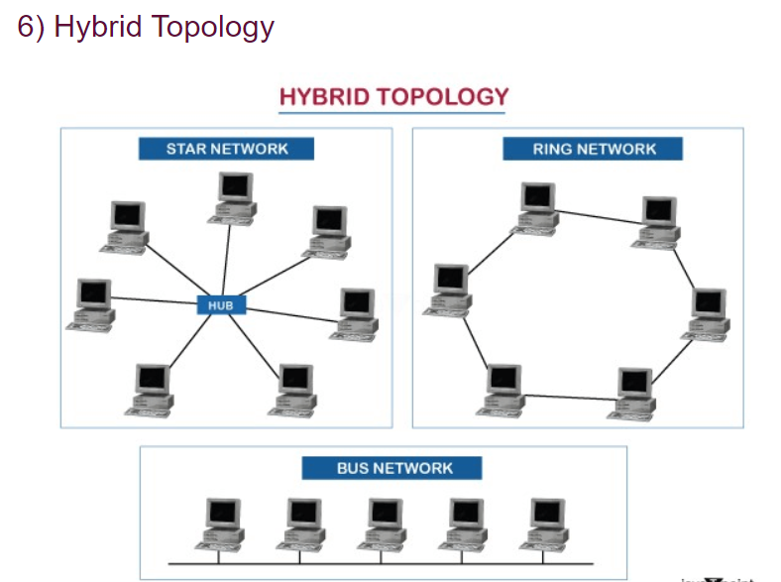

* The combination of various different topologies is known as **Hybrid topology**.
* A Hybrid topology is a connection between different links and nodes to transfer the data.

### Advantages of Hybrid Topology

* **Reliable:** If a fault occurs in any part of the network will not affect the functioning of the rest of the network.
* **Scalable:** Size of the network can be easily expanded by adding new devices without affecting the functionality of the existing network.
* **Flexible:** This topology is very flexible as it can be designed according to the requirements of the organization.
* **Effective:** Hybrid topology is very effective as it can be designed in such a way that the strength of the network is maximized and weakness of the network is minimized.

### Disadvantages of Hybrid topology

* **Complex design:** The major drawback of the Hybrid topology is the design of the Hybrid network. It is very difficult to design the architecture of the Hybrid network.
* **Costly Hub:** The Hubs used in the Hybrid topology are very expensive as these hubs are different from usual Hubs used in other topologies.
* **Costly infrastructure:** The infrastructure cost is very high as a hybrid network requires a lot of cabling, network devices, etc.

# Transmission modes

* The way in which data is transmitted from one device to another device is known as **transmission mode**.
* The transmission mode is also known as the communication mode.
* Each communication channel has a direction associated with it, and transmission media provide the direction. Therefore, the transmission mode is also known as a directional mode.
* The transmission mode is defined in the physical layer.

The Transmission mode is divided into three categories:

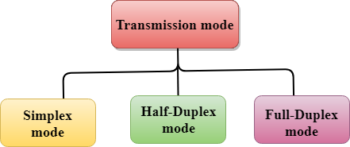

* Simplex mode
* Half-duplex mode
* Full-duplex mode

## Simplex mode



* In Simplex mode, the communication is unidirectional, i.e., the data flow in one direction.
* A device can only send the data but cannot receive it or it can receive the data but cannot send the data.
* This transmission mode is not very popular as mainly communications require the two-way exchange of data. The simplex mode is used in the business field as in sales that do not require any corresponding reply.
* The radio station is a simplex channel as it transmits the signal to the listeners but never allows them to transmit back.
* Keyboard and Monitor are the examples of the simplex mode as a keyboard can only accept the data from the user and monitor can only be used to display the data on the screen.
* The main advantage of the simplex mode is that the full capacity of the communication channel can be utilized during transmission.

### Advantage of Simplex mode:

* In simplex mode, the station can utilize the entire bandwidth of the communication channel, so that more data can be transmitted at a time.

### Disadvantage of Simplex mode:

* Communication is unidirectional, so it has no inter-communication between devices.

## Half-Duplex mode

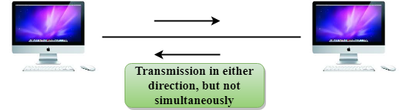

* In a Half-duplex channel, direction can be reversed, i.e., the station can transmit and receive the data as well.
* Messages flow in both the directions, but not at the same time.
* The entire bandwidth of the communication channel is utilized in one direction at a time.
* In half-duplex mode, it is possible to perform the error detection, and if any error occurs, then the receiver requests the sender to retransmit the data.
* A **Walkie-talkie** is an example of the Half-duplex mode. In Walkie-talkie, one party speaks, and another party listens. After a pause, the other speaks and first party listens. Speaking simultaneously will create the distorted sound which cannot be understood.

### Advantage of Half-duplex mode:

* In half-duplex mode, both the devices can send and receive the data and also can utilize the entire bandwidth of the communication channel during the transmission of data.

### Disadvantage of Half-Duplex mode:

* In half-duplex mode, when one device is sending the data, then another has to wait, this causes the delay in sending the data at the right time.

## Full-duplex mode



* In Full duplex mode, the communication is bi-directional, i.e., the data flow in both the directions.
* Both the stations can send and receive the message simultaneously.
* Full-duplex mode has two simplex channels. One channel has traffic moving in one direction, and another channel has traffic flowing in the opposite direction.
* The Full-duplex mode is the fastest mode of communication between devices.
* The most common example of the full-duplex mode is a telephone network. When two people are communicating with each other by a telephone line, both can talk and listen at the same time.

### Advantage of Full-duplex mode:

* Both the stations can send and receive the data at the same time.

### Disadvantage of Full-duplex mode:

* If there is no dedicated path exists between the devices, then the capacity of the communication channel is divided into two parts.

